

CMSC common project 5

Kidus Tilahun



December 3, 2019

project #5

# Test Table

|  |  |  |  |  |  |
| --- | --- | --- | --- | --- | --- |
| **Test Case #** | **Input** | **Actual Input** | **Expected Output**  **Is Magic?** | **Actual Output**  **Is Magic?** | **Did the test pass?** |
| 1 | 1 3 2  5 4 9  6 7 8 | 1 3 2  5 4 9  6 7 8 | No | No | Yes |
| 2 | 10 2    3  4   15  6  7   8   -8 | 10 2    3  4   15  6  7   8   -8 | No | No | Yes |
| 3 | 4  9  2  3  5  7  8  1  6 | 4  9  2  3  5  7  8  1  6 | Yes | Yes | Yes |
| 4 | 1 2 3  4 5 6  7 8 9 | 1 2 3  4 5 6  7 8 9 | no | no | Yes |

# Test #1

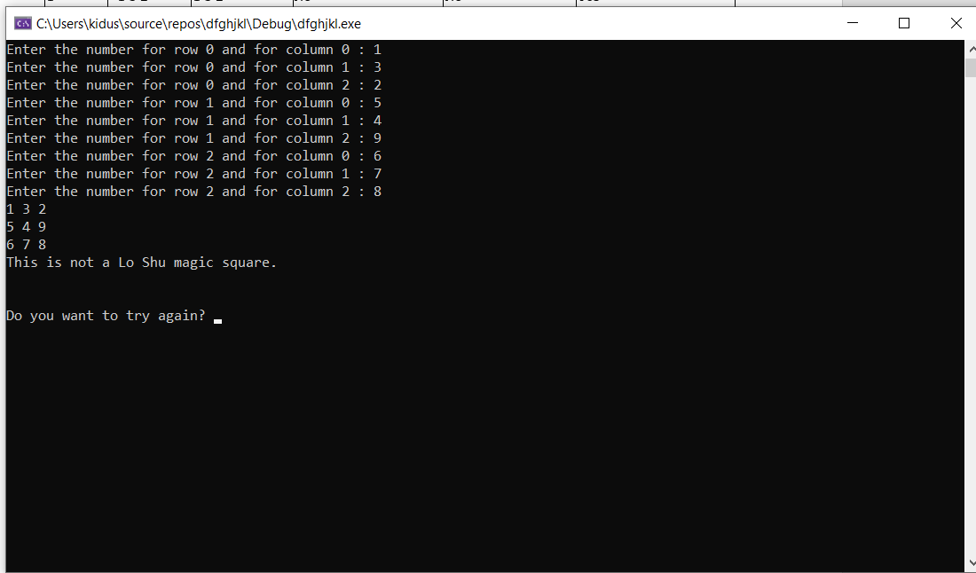

# Test #2

# Test #3

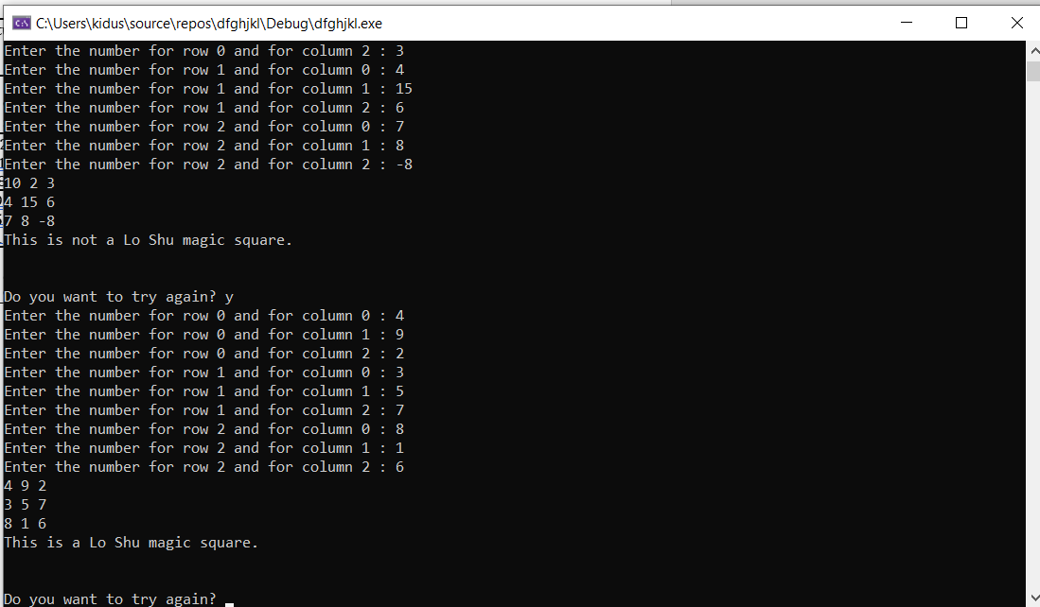

# Test #4

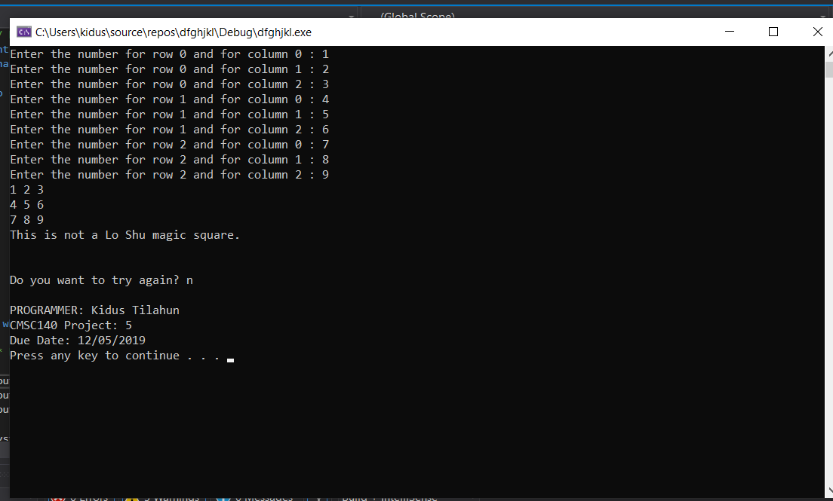

# Lesson Learned

* I have learned how to efficiently use different types of functions in coherence with arrays.